LJ

Design Document for:

**Lost Jade**

“We love game design!”™

All work Copyright ©2021 by LJ

Written by Chongyuan Li, Yanyu Li, Shuxuan Qin, Qian Yu, Luhan Zhao

Version #3.0

12/05/2021

**Table of Contents**

**1. DESIGN HISTORY**--------------------------------------------------------------------------------- 6

Version 1.0-------------------------------------------------------------------------------------------- 6

Version 2.0-------------------------------------------------------------------------------------------- 7

Version 3.0-------------------------------------------------------------------------------------------- 7

**2. GAME OVERVIEW**------------------------------------------------------------------------------ 8

PHILOSOPHY

8

Philosophical point #1------------------------------------------------------------------------------ 8

Philosophical point #2------------------------------------------------------------------------------ 8

Philosophical point #3------------------------------------------------------------------------------ 8

COMMON QUESTIONS

9

What is the game?----------------------------------------------------------------------------------- 9 Why create this game?------------------------------------------------------------------------------ 9

Where does the game take place?----------------------------------------------------------------- 9

What do I control?--------------------------------------------------------------------------------- 10

How many characters do I control?-------------------------------------------------------------- 10

What is the main focus?----------------------------------------------------------------------------10

What’s different?------------------------------------------------------------------------------------10

**3. FEATURE SET**--------------------------------------------------------------------------------------11

GENERAL FEATURES

11

SINGLE-PLAYER FEATURES

12

MULTI-PLAYER FEATURES

16

EDITOR

20

GAMEPLAY

20

**4. THE GAME WORLD**

OVERVIEW

23

WORLD FEATURE #1

25

WORLD FEATURE #2

25

THE PHYSICAL WORLD

26

Overview---------------------------------------------------------------------------------------------25

Key Locations---------------------------------------------------------------------------------------26

Travel-------------------------------------------------------------------------------------------------26

Scale -------------------------------------------------------------------------------------------------26

Objects -----------------------------------------------------------------------------------------------26

Weather-----------------------------------------------------------------------------------------------27

Day and Night---------------------------------------------------------------------------------------27

Time--------------------------------------------------------------------------------------------------27

RENDERING SYSTEM

27

Overview---------------------------------------------------------------------------------------------27

2D/3D Rendering-----------------------------------------------------------------------------------27

CAMERA

28

GAME ENGINE

28

LIGHTING MODELS

28

**5. THE WORLD LAYOUT** ------------------------------------------------------------------------29

OVERVIEW

29

WORLD LAYOUT DETAIL #1

29

WORLD LAYOUT DETAIL #2

30

**6. GAME CHARACTERS**--------------------------------------------------------------------------31

OVERVIEW

31

CREATING A CHARACTER

33

ENEMIES AND MONSTERS

36

**7. USER INTERFACE**--------------------------------------------------------------------------------38

OVERVIEW

38

MAIN INTERFACE

38

COMPONENTS

38

**8. WEAPONS&TOOLS**-----------------------------------------------------------------------------41

OVERVIEW

41

WEAPONS DETAILS

41

**9. MUSICAL SCORES AND SOUND EFFECTS**---------------------------------------46

OVERVIEW

46

SONIC PI

46

SOUND DESIGN

47

Opening Music--------------------------------------------------------------------------------------47

Background music----------------------------------------------------------------------------------47

Character Sound Effects---------------------------------------------------------------------------47

Environment Sound Effects-----------------------------------------------------------------------47

Ending Sound---------------------------------------------------------------------------------------47

**10. SINGLE PLAYER GAME**--------------------------------------------------------------------48

OVERVIEW

48

SINGLE PLAYER GAME DETAIL

48

STORY

48

HOURS OF GAME-PLAY

49 VICTORY CONDITIONS

49

**11. MULTI-PLAYER GAME**----------------------------------------------------------------------50

OVERVIEW

50

MAX PLAYERS

50

SERVERS

50

CUSTOMIZATION

50

INTERNET

50 GAMING SITES

50

PERSISTENCE

50

SAVING AND LOADING

51

**12. CHARACTER RENDERING**---------------------------------------------------------------52

OVERVIEW

52

CHARACTER RENDERING DETAIL #1

52

CHARACTER RENDERING DETAIL #2

53

**13. WORLD EDITING**------------------------------------------------------------------------------54

OVERVIEW

54

WORLD EDITING DETAIL #1

54

WORLD EDITING DETAIL #2

54

**14. EXTRA MISCELLANEOUS STUFF**-------------------------------------------------55

**1. Design History**

This is the design history of our game, Lost Jade. In this section, we are showing the different versions of the design for our game. We are doing a design document and a website, but not the actual game. This section is for us to document progress as well.

**Version 1.0**

Version 1.0 is the first version of our game, Death of Anna. In this section, we split the work for each of the group members and did the initial design of the game.

1. Added game overview, including the philosophy of the game and common questions.

2. Added feature set, including general features, multiplayer features, editor, and gameplay.

3. Added the game world, including an overview, world feature #1 and #2, the physical world, and the rendering system.

4. Added world layout.

5. Added game characters.

6. Added user interface.

7. Added weapons.

8. Added musical score and sound effects.

9. Added Single-player game and Multiplayer game

10. Added Character rendering.

11. Added world editing.

**Version 2.0**

Version 2.0 is where we added more information and detail on the previous version. We have added more sections to that.

1. Added Camera, Game engine, and Light models in the game world section.

2. Added images.

3. Finished the story setting.

**Version 3.0**

Version 3.0 is our final version of the game, and we also created a website from that.

1. Created a website from the design document.

2. Fixed format.

**2. Game Overview**

**Philosophy**

**Philosophical point #1**

The name of our game is Lost Jade, Anna is the Queen of the kingdom and she died. This is a puzzle game where the King gives a bounty to whoever can find out why the Queen died. Players are bounty hunters that want to solve the puzzles in the game in order to get the bounty. The puzzles we designed are really interesting and will make the players want to solve all the puzzles.

**Philosophical point #2**

As of right now, we only plan to release a PC game. The reason is that the game won’t require many buttons. We plan to do a 2D game, and a keyboard and mouse are sufficient for our game. If the game sells well, we will consider a 3D game that can be run not only on the PC but also on many game consoles like Playstation and Xbox.

**Philosophical point #3**

The game we designed is not simply a puzzle game but involves many features beyond that. We added fighting features to let the players compete with each other to get the key or solution to the puzzle. We also added features that the players can fight with a monster in order to escape from a trap to get the key to the puzzles.

**Common Questions**

**What is the game?**

Our game is called Lost Jade, and Anna is the Queen of the Kingdom. The king loves her really much but she died mysteriously. The King gives a really big bounty for people to find out the real reason for Anna’s death. In the actual game, the players are bounty hunters that want the bounty from the King. The players fight with other bounty hunters to get the key to the puzzle, and they are able to fight the monsters on the route to the key to the puzzles.

**Why create this game?**

The original thought of this game came from Cicada 3301, an enigmatic organization that posted three sets of puzzles online between 2012 and 2014. The organization posts different kinds of puzzles online and all over the world to find the smartest. They claimed that the people who solve them can join them. Although we are not sure whether this organization is real or not, I found out the puzzles are really interesting. Then we decided to do a puzzle game. Since Cicada 3301 releases puzzles online and many of the puzzles are ciphers that can be checked online, we decided to do a puzzle game that is more like medieval-type mystery puzzles. We found out it’s boring to just solve the puzzles, so we decided to add some fighting features so that players can fight with each other and fight with the monsters.

**Where does the game take place?**

The game takes place in a fantastic world where monsters and mystery exist. Although the background is based on Europe in the Middle Ages, the world has more features than that. The majority of the game takes place in old castles, more like a maze. Each maze has some kind of key or solution to the death of Anna. Players need to solve all the puzzles in order to find out why Anna died.

**What do I control?**

The player with control is a bounty hunter. They will be able to choose the appearance they like and create them. The player will be able to control the bounty hunter to move and fight with each other.

**How many characters do I control?**

Each player can only control one character. Players are just like the bounty hunters in the real game where they try to solve the puzzles to get the bounty.

**What is the main focus?**

The main focus of the game is for the players to be the first one to solve all the puzzles in order to know the reason for Anna's death. They are able to find a variety of great items during their adventure.

**What’s different?**

This game is not just a simple puzzle game. Instead, players are able to communicate, trade, or fight with each other to get the key to a single puzzle. This makes the game more interesting.

**3. Feature Set**

General Features

The general features of this game are as a list:

1. Table of Contents
2. Main Menu
3. Character Creation
   1. -one player
   2. -two players
   3. -three players
   4. -four players
   5. -multiple players
4. Main Gameplay Screen
5. Gamemode Selection
   1. -Single-player
   2. -Multiple players
6. Crew
7. Shop
8. Exploration
9. NPCs
10. Inventory
    1. Game Options
       1. -Save game
       2. -Writing saved Games
       3. -Deleting Saved Games
    2. Load Game
       1. -Load Game Screen
       2. -Loading saved Games
    3. Quit Game
11. Music Volume
12. Dialogue Volume
13. Language Selection
14. English(U.S)
15. English(U.K)
16. Chinese(Simplified)
17. Chinese(Traditional)
18. French
19. Spanish
20. Subtitle Toggle
21. Vibration Toggle

Single-player feature:

* Process and Quests
  + A single player can ask and complete all tasks by himself/herself.
  + The instance level should set difficulty based on his/her current level.
  + All clues collection is done individually.
  + Completing instance and upgrade weapons is individually
  + All tools and items can only trade with NPCs.
  + The Player can track the tasks at the map or taskbar.
* Money
  + All money gained from tasks or instances is individual.
  + Money is kept all the time in the process of the game.
* Experience
  + The player can gain experience points by completing different tasks.
  + The player can gain experience points by completing the collection of clues.
  + The player can gain experience points by finishing instances and killing monsters.
  + The maximum of experience points is 100 levels. If a player reaches the maximum experience points, he can still get experience from tasks or instances, but the experience would be directly transferred to corresponding money.
* Material
  + The players can collect material in the forest.
  + The players can collect material by completing tasks.
  + The players can collect material by finishing an instance and get the rewards.
* Medical
  + The player can make hematinic by using different material
  + The player can make magic potion by using different material
  + The player can make other medical with proper reagents table
* Skill
  + The player can upgrade their characters’ skill by level points
  + A character would get one level point per level, 100 level points for maximum.
* Time
  + This game is designed to have a day and night in 24 hours.
  + Players can pause time anytime while playing the game.
  + In other circumstances, time will go on without pause.
* Map
  + The player can check the little map at the right corner of the game.
  + Large map: Players can click the “m” button to view the large map.
* Item bar
  + The player can check their own items and tools at the item bar by clicking the “I” button.
* Save game & load game
  + The player can save the game in regular time. The game can not be saved while instances.
  + The player can load their game by clicking load game in the main menu. The game would resume the last time they played.
* Huge world

In AD 691, The ancient kingdom was shown as a large map. The mountains, rivers, forests, buildings were all formed as the ancient type. Players can play a role or multiple roles in this large map, go inside different castles to collect multiple clues, or players can come to cross mountains to reach different task points to accept tasks and finish tasks.

As different characters, they can explore this world in different ways.

* 3D graphics

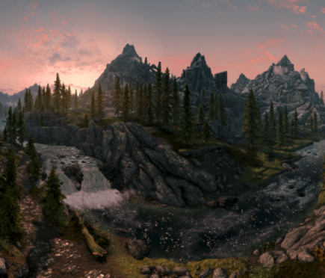

In this game, we design it to make it a roleplaying game. It has 3D mountains, rivers, and other features like ancient buildings. These graphical items are designed to make it more realistic and make players feel the AD 691.

We can use the “Editor X” as the main application platform to create what we want.

* 32-bit color

Most monitors would support 32-bit color depth.

32 bit occasionally means 32 bits per channel (128 bits total per pixel). And, a lot of the time 32 bit per channel uses floating-point numbers, rather than integers.

The [OpenEXR](http://openexr.com/) format supports 32-bit float channels. That might sound excessive, but it’s often used for VFX and rendered material, where heavy processing or color correction may be involved, and large files are less of a concern.

Multiplayer Features

In addition to the single-player mode, our game also has a multiplayer mode that can be used by four players at the same time. Once we choose to select multiplayer on the main menu, we can choose to join a game with friends or type an ID in the top corner to join a friends' lobby, if they have a code to share.

If we want to host a game, we can just click New Game and set up our own multiplayer match. We can send an ID code or host it in a Local area network to let our friends join the game. Also, we can change the permissions of the lobby from public to private if we do not want random people to join the game, or we can set a password. At the main menu, players can select the heroes or characters, once players are ready, you can start the game.

* Start a new multiplayer mode
  + From the main menu, choose the multiplayer mode for specific players
  + Make sure to add each player who will join.

Multiplayer mode is mostly identical to single player mode, though certain features are specific to multiplayer only.

* Process and Quests
  + Each player should keep their task progress on the individual level, but players can work together to help other players with their tasks.
  + Each players’ type of equipment and weapons should be upgraded individually, but the tools for upgrading can be traded.
  + Collecting the clues can be grouped, and each player can get their own set of rewards.
  + Rewards of the instance can be grouped, and they are equal.
  + Tasks set difficulty based on the average level of each player.
  + The Player can track the tasks at the map or taskbar.
* Money
  + Money can be shared between each player or it can be owned individually.
    - It can be set at the beginning of the game, when it is set to be shared, then every player can be shared, and all money can be sent equally to each player.
    - When choosing not to share money, they can get money individually in the whole game.
* Experience
  + Each player can have their own experience points.
    - In an instance, those who kill more monsters can get more experience.
    - Players can get experience by completing different tasks in the process.
      * The common tasks’ experience can be allocated equally to each player who attends this task.
      * Individual tasks’ experience should be distributed directly to those who complete it.
  + The maximum of experience points is 100 levels. If a player reaches the maximum experience points, he can still get experience from tasks or instances, but the experience would be directly transferred to corresponding money.
* Material
  + As the same as single-player mode.
* Medical
  + As the same as single-player mode.
* Time
  + This game is designed to have a day and night in 24 hours.
  + Players can pause time anytime while playing the game by individually
  + When in a multiplayer game time
    - The host can pause the game by using the pause key, and it should be agreed upon by other players.
    - If all players are in a cutscene, they can choose to skip, or time will pause.
  + In other circumstances, time will go on without pause.
* Map
  + The player can check the little map at the right corner of the game.
  + Large map: Players can click the “m” button to view the large map.
  + Viewing maps is individual, it will not be affected by other players.
* Save game & load game
  + The player can save the game in regular time. The game can not be saved while instances. When one player quits the game, other players can still save their own process at any time.
  + The player can load their game by clicking load game in the main menu. The game would resume to the last time they play, it would not be affected by other players.

Chat

* Chat is a feature inside the game, it will allow players to communicate with other players directly in-game.
* Players can type in the communication bar, all communication will appear immediately in the bar.

Command - It can be run in the chat bar

* Pause: Pause the game at the current time for players.
* Resume: Resume the game if it has already paused.
* Clear: Clear all previous chats.
* Stop music: Players can stop the background music.
* Emojis: Players can input emojis to express their feelings.

Platform

* It only supports PCs.

Editor

* The editor is easy to use.
* We can use GameMaker Studio 2
  + It uses some C programming language to customize our game.

Gameplay

* Players can start a new single-player or multiplayer game by choosing from the main menu.
* Players can resume/load the last game.
* For single-player mode:
  + Players can turn the base game.
  + Completing all tasks and collecting all materials, clues, equipment by themselves.
  + Go find NPCs to start single-player communication.
  + Explore the whole map individually.
  + Pause/resume game at any time.
* For multiplayer mode:
  + Some decisions are made collaboratively by all players:
    - Players can communicate with NPCs,
    - When to join an instance
  + The players can share their clues
  + Each player has their own skills, and they have their own property like attack, defense, and HP, etc.
  + Each player can enter a departing area or enter the same area together.
  + Multiplayer mode can begin some group communication with NPCs.
  + Interactions between multiple players:
    - Players can exchange the items they collect, and some common equipment
    - Each player can check other players’ equipment, HP, and the medicament they have
    - Each player can trade the weapons they can not use.
* Find different instances to collect materials, clues, etc.
  + In instances, players can use different characters’ skills to kill monsters individually or by the team.
    - Multiplayers can cooperate with others to finish the instances. The instances would level up by the number of the players.
* Game balance
  + All tasks and instances in the process would be leveled up with the player’s level.
* Winning the game
  + To win the game individually
    - A player should collect all the clues and find out the reason why the queen was dead.
  + To win the game in multiplayer mode
    - All clues should be collected, players can help each other with it. And find out the reason why the queen was dead.

**4. The Game World**

**Overview**

715 AD, there was a glorious kingdom on the Eurasian continent. The people there were prosperous, and the whole kingdom was shrouded in white light, exuding a gentle and luxurious atmosphere. Stepping on the land of this kingdom, you could see flawless jade everywhere. This kingdom was famous for jade, and the output of jade here was far ahead of other countries in the world. Not only was the output gratifying, but the quality of these jade was also the best. The surrounding kingdoms are yearning for this carved and jade-lined land, calling it a land blessed by God. The history of this kingdom was as well-known as its prosperity: 24 years ago, it was an ordinary small country, until the people here ushered in their queen.

​

In 691, a beautiful girl came to this land. She had slender skin and a slender figure, her blonde hair was covered by a dusky halo. The sun was good the day she arrived, shining on the hem of her pure white skirt as if a god descended from the earth. People were fascinated, looking at the girl infatuatedly, and the girl stretched out her hand to the belated king.

​

She then became the queen of this kingdom. The king dedicated all the best things in this country to her, and the queen brought a piece of round jade that was flawless to worship. This jade was like a night pearl, exuding a faint fluorescence. The king had never seen this kind of treasure and ordered it to be inlaid on the palace for his people to admire. Looking from a distance in the quiet night, it felt like the moon in the galaxy falling into the world.

​

The good times didn't last long. Even though the king loved the queen in every possible way, the queen died suddenly 20 years later. On the night of the queen's death, the moon inlaid in the palace suddenly shattered like a premonition. With everyone's mourning for the queen came the surprise of discovering beautiful jade. After the queen's death, this land suddenly burst into a steady stream of jade that could be mined. The people called this the queen's blessing. So far, the land blessed by God broke into the world's vision.

​

Fifty years later, in 765, all these beautiful scenes were suddenly broken, and all the jade that was discovered on this land disappeared overnight. What followed was a hell-like scene on earth. The prosperous scene no longer continues. Later on, the land blessed by God no longer exists. This kingdom is then called the Lost Jade.

​

In 810, the new king of this kingdom received a foretaste in his dream. The decline of the kingdom was not accidental, and the Jade Queen did not die of illness. He claimed that as long as he knew the reason for the decline of the kingdom, he would be able to restore the kingdom to its former prosperity. The new king used the last jade in the royal family as a bounty and issued a reward to find the cause of the decline of the kingdom and the death of the former queen. So far, bounty hunters from all over the world have stepped into the Lost Jade, and the king asked a witch to cast a spell. The bounty hunters were sent back to the land blessed by God in 691, and the truth is to be revealed shortly.

**World Feature #1**

The game world is an open world, and by this, the players are able to roam within the map and interact with all the components. The interactions players make will impact the plot development and the side stories will also be displayed once the condition is fulfilled. However, the mainline of this game would be completed without extra interactions as long as players are scrupulous enough to find all the clues. Also, the choices players make through the game will also impact the following plot development, one may make the game easier and more interesting, the other may slow down the pace and cause some unexpected circumstances.

**World Feature #2**

In the game world, players will be initialized with different jobs and skills which would help them explore the kingdom. The default setting would be a bounty hunter with vampire-like speed and sense. There will be other careers implemented like witches, assailants, priests, etc. In single-player mode, those could be selected, and in multiplayer mode, the careers and skills will be randomly distributed. Once distributed, the players cannot change the setting till the current game ends. Different careers and skills have different information laid within the game, waiting for the players to discover.

**The Physical World**

**Overview**

The game will be established greatly based on the physical world, except fictional elements will inevitably exist. The movement of one character will be designed based on human reactions. The architecture and environment including paths, houses, day and night cycle, temperature, and weather will also refer to the real world in order to create a sense of reality.

**Key Locations**

The game world is created based on Edinburgh and its surrounding towns. And in the game, the key location is the whole castle, but the towns and cities around it will also have a significant impact on the storyline.

**Travel**

The players use “W”, “S”, “A”, “D”, or the up arrow key, down arrow key, left arrow key, right arrow key to move the character.

**Scale**

The scale would be self-adapted within the game while the players could choose to change. The default scale would be 18:1.

**Objects**

Jade - all the jade described in the game world will not have a corresponding feature excited in the real world.

**Weather**

All the weather situations would be contained in this game, they are stored in a particular order and will be delivered to the players randomly.

**Day and Night**

There is a day and night mode in this game. They will be used for side stories.

**Time**

The day mode starts from 7:00 to 18:00 while the night mode starts from 18:00 to 2:00. 2:00-7:00 is forbidden for game playing to avoid health problems. Different times contain different side stories.

**Rendering System**

**Overview**

Give an overview of how your game will be rendered and then go into detail in the following paragraphs.

**2D/3D Rendering**

Describe what sort of 2D/3D rendering engine will be used.

**Camera**

The camera type is movable, we can use a movable camera to turn, especially in some tight spaces within the game. We can use arrow keys or the mouse to control the view in the whole world.

**Game Engine**

Inside the game engine, it supports 2D and 3D rendering, user interface key mapping and other UI components. It includes animation engines, audio engines, multiplayer and networking tools, and the IDE for custom scripting. The rendering engine is for handline memory management and buffering for some images.

**Lightning Models**

By applying Blinn Phone lighting models to support our game. And we can add some image based lighting to our list of lighting models.

**5. The world layout**

**Overview**

As described, the game Lost Jade originated from Cicada 3301 after the organization came up with sets of puzzles, where they posted online the three puzzles to inquire which puzzle was the smartest. The game was a fight between monsters and players in a mysterious world, where the game was generated after Anna the Queen was killed and the king came up with a bounty for anyone who will find out about the murder of the queen (Brock et al, 2018). The layout of the game which marks how it is arranged in the world is set according to the era feature of the game, which implies that as the game was created in the middle Ages, the game hence took place in old castles or in the open field where there was mountains, rivers, forests, valleys, and another physical world.

**World Layout Detail #1**

The entire world in the ancient days in the 691 AD, the kingdom where the incident which resulted in the game was shown using a large map, which was covered by natural features, the forests, mountains, valleys, rivers, and the man-made features, the buildings, and other construction which constituted into the layout of the game, especially that it took place in an open where they players could hunt against the monster, and they could play different various roles in the large map that represented the world layout, they could enter inside castles or buildings, the players could run down the valleys, up the mountains, inside thick forests, across many physical places to finish their tasks.

**World Layout Detail #2**

The world layout of the Lost Jade game is mostly acted in unless when there is the existence of, the architecture of the physical world should portray the ancient days, be it in buildings, paths, and other natural resources. Therefore, the design of the architecture of the world layout of this game should contain 3D graphics, which makes the appearance of the world layout of the game realistic and make the players feel like they are really in the real world, as in the past the color used was mainly black and white, hence using it in showing the mountains, and other physical features brings the real-world layout of the game.

**6. Game Characters**

Overview

This game involved many distinct well-designed characters including four player-controllable characters with different background settings, skills, and weapons, many non-player characters contributing to the game process and experience, and many monsters with specific features. Each player is able to select one of the four heroic bounty hunters using an active selecting wheel. We also included a system by which the player can personalize the character, such as modifying the appearance or clothing of the character.

Four characters

*Camilo, Sword of the Kingdom - The most respected paladin of the Kingdom*

The story of Camilo is widely spread among the Kingdom. This young man is the bravest and the most trusted knight of the King and has excellent battle skills on using his sword to defeat his enemy, thus he is awarded the title of “Sword of the Kingdom”. Upon hearing about the King’s bounty, he is willing to put his best effort to serve the King and accomplish the task. His experience of fighting against different kinds of enemies will help him to approach the fact of the death of the Queen.

*Calanthia, Light of the Sanctuary - The most talented mage from the Royal Sanctuary*

Calanthia is not only a pretty young lady but also the most talented mage from the Royal Sanctuary of the Kingdom. She was raised by the most sagacious mages in the sanctuary and inherited the wisdom of these excellent magic casters. People praise her as “the light of the Sanctuary” not only because of her talent in magics, but also her pretty and charming appearance. She is extremely talented at fighting those unknown and mysterious monsters deep in the castle by casting different incantations using her treasured ring. Her rich knowledge about the mysterious monsters and enemies will definitely assist her to safely seek those secrets that most bounty hunters could not approach.

*Fallam, Supreme Alchemist - Master of alchemy, medicine and poison*

Alchemists are always very respected because of their ability to solve all kinds of different problems. Fallam is the noblest and experienced one among the alchemists in the Kingdom. Even though this senior lady is not good at casting magics nor waving swords, she is very proficient about blending complicated medicines to heal or boost her allies, or fatal poisons to eliminate her enemies. She could produce useful reagents by just using some common ingredients in an elusive way, which might be recorded deeply in her mind from a long period ago. She is willing to explore more knowledge and secret prescriptions hidden in the castle, thus accepting the King’s bounty request.

*Jalmun, Silverseeker - The most experienced and professional bounty hunter*

No one is better than Jalmun in the aspect of seeking clues and investigating surrounding circumstances in the unknown regions. This senior man is the most experienced bounty hunter and the most skilled user of bow and arrows. He spent most of his life seeking his target in the wilderness and thus developed sensitive feelings about the risk and clues around him. He could protect himself from unknown monsters and survive under any extreme conditions with his skills on bows and traps. He always wants to challenge the most difficult puzzles and dangerous bounty requests. The King’s bounty request will definitely be his target of superlative priority.

**Creating a character**

Selecting Wheel

We included a selecting wheel to actively show the characters along with their skills, weapons, and personalities. The player will be able to rotate the wheel and check with the characters back and forth. The player could also look into the background settings and the tutorial of skill usage of the character.

Personalize the character

Appearance

We included a system in which the player is able to modify each part of the character’s appearance. You can adjust the size and position of every component on the character’s face in a reasonable range. For example, you can design a character that has large eyes and a smiling face or another character which has small eyes and a serious face. You can also modify the shape of the character, such as the height, weight, beard and hairstyles, hair and skin colors, or even the length of arms and legs. All of these settings will be limited in a reasonable and proper range, and will not influence the game balance at all, such as changing the hit-box or the attack range of the character.

Clothing

The player can also set the clothing of the character. We have provided some patterns for each character, and the player will be able to choose one of the basic patterns. The player can modify the colors or styles of each component of the pattern.

**NPC**

Overview

There are many non-player characters that are associated with the plot of the game. They may provide some clues if the player has a conversation with them, or release requests and corresponding awards that will promote the players if they can accomplish the request. They could also provide some services to the player, such as upgrading or repairing the weapons, as they are also your assistant in accomplishing the King’s bounty request.

Three Main NPC

There are three main friendly non-player characters: **Butler, Chef, and Servant.** They will distribute different requests along the game process to assist the players, which are not required tasks but useful opportunities for promoting the main character.

Butler will award the player a refined and solid shield to defend himself or herself from the monster’s attack. He knows about all the secrets of the King’s treasures and is willing to protect them at the cost of life. The shield is the treasure of the King which will only be awarded by the most contributing warrior. **Camilo will receive a larger promotion than other characters upon receiving the shield.**

Chef will award the player some useful consumables such as delicious foods to promote the character or oils to weaken the monsters. He has served the King for decades and is professional about cooking all kinds of delicious and nutritious delicacies. Most of the chef’s requests should be easy and repeatable. Fallam is able to apply these consumables with higher efficiency than other characters.

Servant will award the player a whole set of armor with protective magics on onside. She was accepted into the castle and received much grace from the Queen from decades ago. This set of armor will be extremely helpful in the final battle with the leader of the monsters. Each character will receive the same promotion upon receiving this treasure.

**Monsters**

Overview

The mysterious death of Queen Anna is the core of the King’s bounty request. Through the process of the game, the player will discover some different kinds of monsters in the castle. The player can choose to fight against them directly and gain useful loot and clues from them. Or the player can use some strategies to avoid the monsters and concentrate on solving those puzzles and collecting clues. Overall, fighting against the monster is an important part of the game experience.

Low-level monster

There are two types of low-level monsters, **spiders** and **thieves**, which are relatively common in the castle.

Spiders

There are many spiders living at each corner of this old castle. The spiders could only attack the character in melee range, but their attacks would perform different influences on the character. There are three different types of spiders which are distinguished by their colors. The red spiders will make the player bleed, thus reducing the character’s hp periodically. They may explode in several seconds after being killed by the player. The blue spiders will reduce the moving speed of the character, thus increasing the opportunity of the character to be attacked again. The green spiders will make the player poisoned and disturb the character’s senses. They will also produce a poisonous pond as they are killed by the player. Players could gain materials from these spiders to produce traps which are useful to limit higher-level monsters and protect the character. **Jalmun will be more professional in producing these traps than other characters.**

Thieves

There are many greedy and dangerous thieves who covet the treasures in the King’s castle. They are willing to rob any adventurer who wants to step into the castle and compete for wealth with them. They are tricky ranged monsters using darts from the shadow, which are hard to realize and defend. If you could defeat them, you can reuse their darts as an excellent ranged weapon.

High-level monster

There are many elder and mysterious guardians who are protecting the secret of this old long-inherited castle. There are many hidden treasures of the previous Kings behind these guardians who are extremely difficult to defeat compared to those low-level monsters. If you can defeat any of them, you will be awarded a special piece of compass or map pointing to the fact of Queen Anna’s death. **Calanthia is very talented at specifying the directions and symbols on these old maps, and is knowledgeable about applying these compasses.**

Leader of monsters

The leader of monsters is an evil wizard who could command scary demons and cast crucial curses. He is located at the depth of the castle and obtains the core piece of clue about the death of Queen Anna. He has a fanatical thirst for magic powers, and wants to seize the mysterious power from the Queen’s Jade. Thus he invaded the castle, assassinated Queen Anna, and plundered the blessed power from her. The player is required to defeat him to pass the game. This will be the most difficult battle in this game, thus the players should collect all the resources they could discover to reach the victory.

**7. User Interface**

Overview

The user interface is one of the most significant parts of a game. We have designed different interfaces under many situations such as conversation, battle, inventory, and puzzle solving. We included many well-designed components to represent the health, the magic power, the energy, the experience, and the weapon of the character. We could also notify the player about directions by involving a steering compass bar.

Main Interface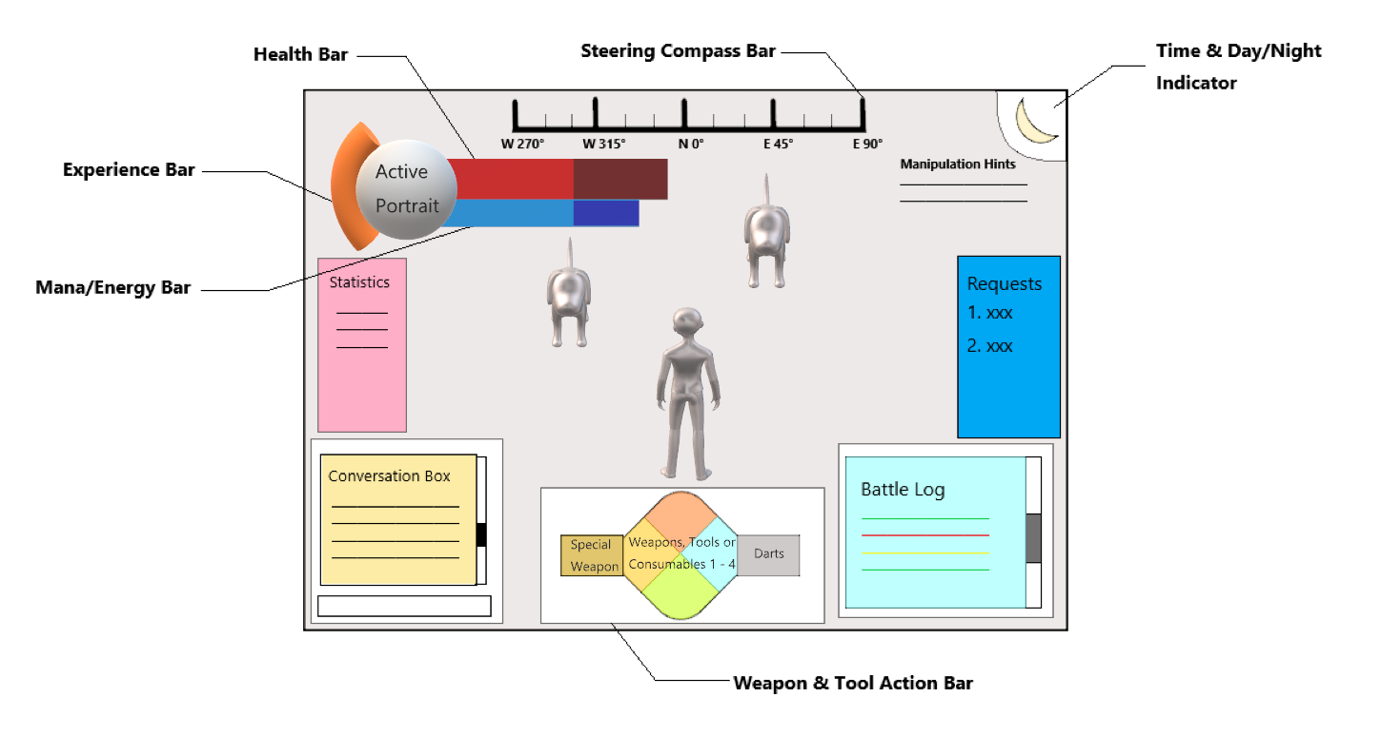

Components

1. Health bar - A red bar represents the character’s hp

2. Mana/Energy bar - A bar represents the character’s battle resource, whose color depends on the character’s ability

3. Experience bar - A bar represents the level and current experience of the character

4. Weapons & Tool Action bar - Available weapons and tools of the character and their corresponding shortcuts

5. Steering compass bar - A compass style component which assists the player to recognize different directions

6. Conversation box - An interactive box involving the information about the conversations between the player and the NPC, or the chats among different players

7. Statistics - Some useful statistics associated with the process of the game

8. Time - Current time and day/night status associated with the weather system

9. Request bar - All the requests received by the player and their corresponding statuses

10. Manipulation hints - Tutorial and hints about manipulating the weapon/tool

11. Battle records/logs - Combat text including damages, buffs/debuffs, and loots

Setting

Save / Load games

Graphic / Audio settings

Keyboard binding

About the producer

Inventory

Character attributes

Inventory of items (weapons, tools and consumables)

Clues collected / Puzzle discovered

**8. Weapons & Tools**

Overview

There are many well-designed interesting weapons and tools that contribute to the game experience. Each one of the four characters will obtain a special non-exchangeable weapon that fits the character’s ability and personality. Additionally, there are three types of useful equipment from the non-player characters, as the reward for accomplishing their requests. What’s more, there are three types of weapons or tools in the loot of monsters, which are efficient supplements to improve the opportunity for the player to pass the game. Each character will gain better promotion than others on one special weapon or tool among the seven non-character-owned weapons and tools.

Special character-owned weapons

*Sword - Camilo, Sword of the Kingdom*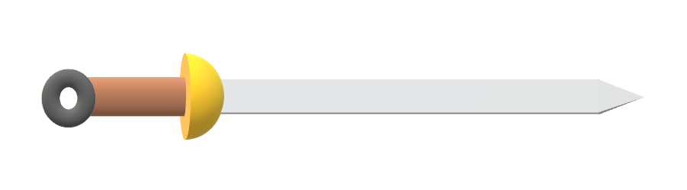

**A refined metal sword which is very reliable while fighting against the enemy.** As the best user of swords in the Kingdom, Camilo always treasures his weapon and applies it properly, as how the Kingdom recognizes his value and praises him.

*Magic Ring - Calanthia, Light of the Sanctuary*

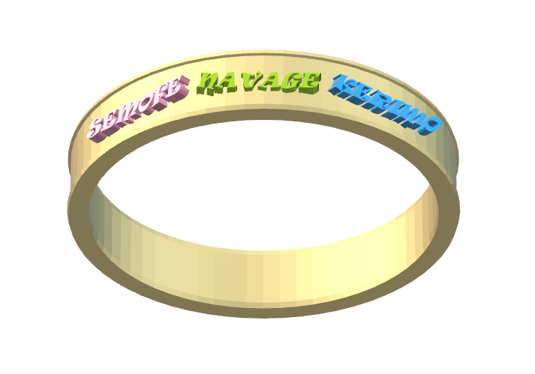

**A magical ring which has been inherited for centuries in the Royal Sanctuary.** There are many ancient powerful inscriptions on the ring, which could respond to the user’s spells and help the user accomplish many different goals. Calanthia is very familiar with the powerful inscriptions on this spellcasting equipment and applies them as her strongest weapon.

*Blending bottle - Fallam, Supreme Alchemist*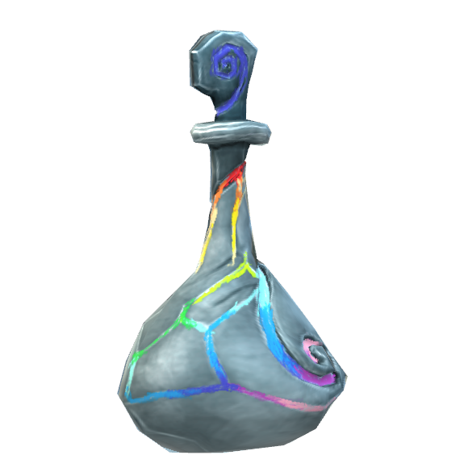

**A colorful blending bottle which contains infinite secrets of alchemy**, which is the treasure dreamed of by countless alchemists. Only could Fallam, the best and eldest alchemist, obtain enough knowledge to blend many different reagents from this single bottle and apply them on distinct targets with a proper dose.

*Bow and arrows - Jalmun, Silverseeker*

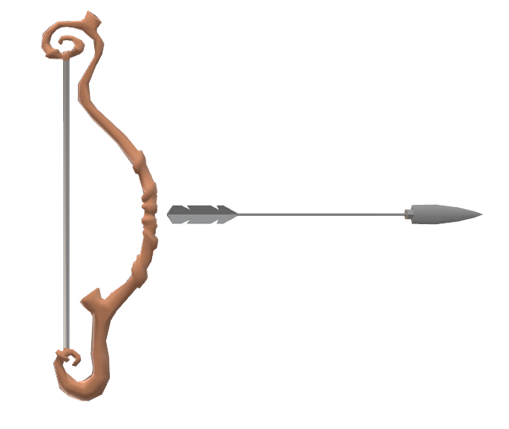

**A stable and durable wooden bow, along with some sharp metal arrows.** This is all that an experienced bounty hunter will need to fight against his enemy. Jalmun never lost any of his targets or got approached by any dangerous creatures depending on his excellent skill to apply his bow. He could finish the fight with only one shot from tens of meters away from the monster even before the monster realized his existence.

**Non-character-owned weapons & tools**

Loot from monsters

*Trap - Spider*

Players can set up traps to protect themselves or lure the monster they want to defeat. These traps are made of spider silk and fiber, which can be found in the loot of any type of spider. A trap will produce different influences onto the enemy, such as bleeding, reducing speed, or poisoning, which depends on the source of the spider silk.

*Dart - Thief*

Players can throw these fatal darts to attack any enemy obstructing their investigations, and also trigger some secret mechanisms in an easier way. These darts could be easily found in the loot of the thieves, and could be upgraded with some other special and rarely found materials from the thieves.

*Treasure Map & Compass - Elder Guardian*

There are many pieces of treasure maps and compasses in the loot of elder guardians. A player could integrate a piece of map with the corresponding compass to find a location where an important piece of clue about the death of Queen Anna is hidden. Exploring more treasure maps will lead the player closer to the goal of the King’s bounty request.

Request rewards

*Shield - Butler*

This magical shield is awarded to the player who accomplished the request of Butler. Upon being equipped, the shield will decrease the damage taken by the character from the attack of monsters with a fixed percentage.

*Food & Oil - chef*

The chef could produce nutritious food to improve the character’s ability or oil to weaken the monsters. Players who accomplish Chef’s request will be able to select some rewards, such as the food to increase their hp recovering speed, attacking damage, or moving speed, and also the oil to increase the damage taken by the monsters or limit their actions.

*Magic Armor - Servant*

This magical armor was blessed by the power of Jade, which could defend most of the fatal curses and the flame of demons. People who accomplish the request of Servant will be awarded this valuable armor. It will be extremely useful in the battle with the wizard who is the leader of monsters in the castle.

**9. Musical Scores and Sound Effects**

**Overview**

There will be various musical sounds in our game. We are using Sonic Pi, a coding synthesizer that we can code and make music. We have a short opening rhythm and an ending rhythm when the players successfully solve a puzzle.

**Sonic Pi**

Sonic Pi is a coding synthesizer and its website is https://sonic-pi.net/. We can use this program to code and make sounds. This is a unique language and it is perfect for games background music.Below is a sample of our musical sound.

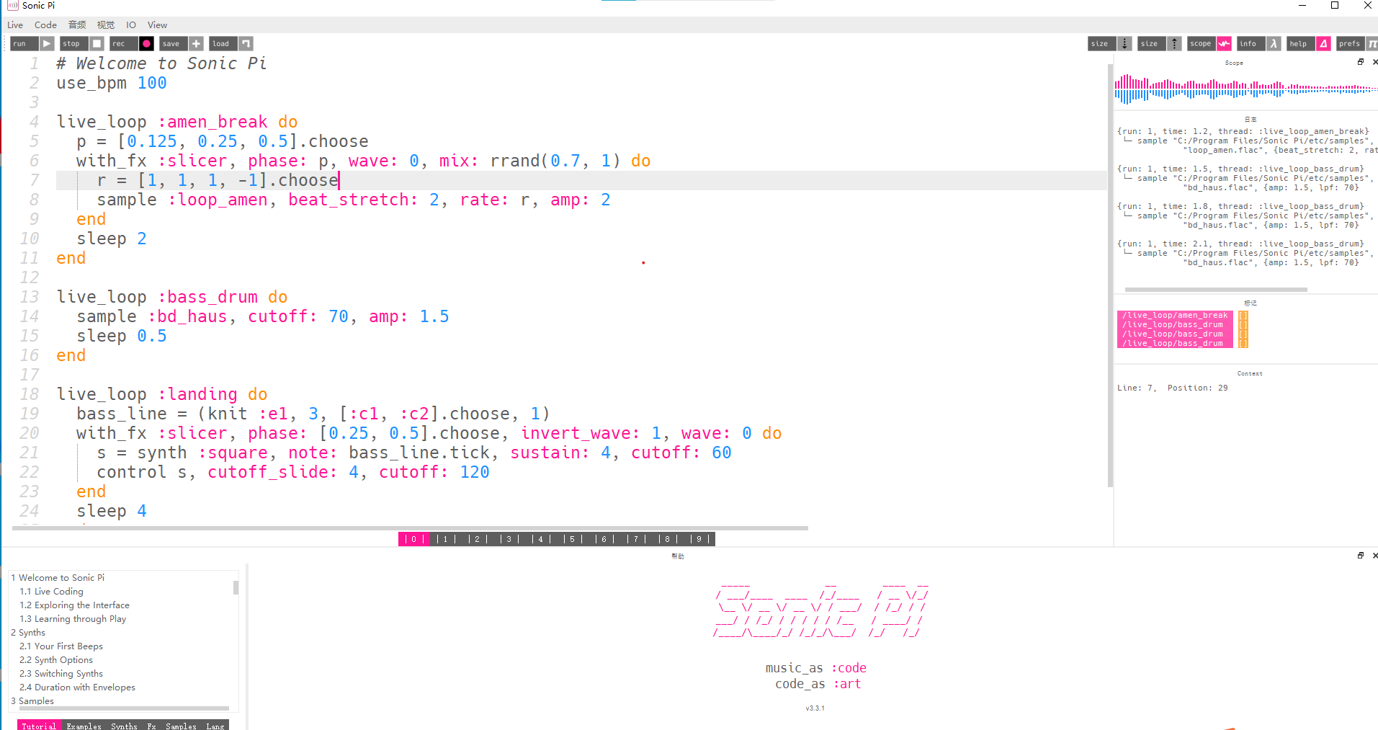

**Sound Design**

Opening Music

There is a short 30 seconds rhythm at the beginning of the game, where the player open the game. The music will be played when the player is on the menu page. The music is horrible and fearful at the beginning because we are entering a mysterious world/

Background music

There will be background music all over the game. There will be background music when the character is moving or solving puzzles. The background music will be quiet but scary.

Character Sound Effects

There will be sound effects for the following actions taken by the player. For example, when the player opens a door, closes a door, walks, or fights with others.

Environment Sound Effects

There will be environmental sound effects. When the players discover a new puzzle, a joyful sound will play. When a player solves the puzzle, a cheerful sound will play.

Ending Sound

There will be a 30 second powerful sound played when the player solves all the puzzles and discovers the reason for Anna's death.

**10. Single-player game**

**Overview**

The single player game is set to be played offline and there won’t be any connection to the Internet. The players can make their own characters and try to solve the puzzles themselves.

**Single-player Game Detail**

In the single player game, there will be NPC bounty hunters that are trying to solve the puzzles as well. The player can fight with them and get their puzzles. The player also needs to fight with the monsters when they are trying to solve the puzzles.

**Story**

You are a bounty hunter at the kingdom. Many years ago, you met Anna before she became the Queen. She is so beautiful that you fall in love with her. However, you are not brave enough to say it until she becomes the Queen. You think she is enjoying her happiness as a Queen so you prepare to hide the secret forever. All of this came to an end when Anna died. You want to get into the palace to search for the truth, but you are not able to get in. Now, bounty hunters from all over the world came to this kingdom for the reward of the Jade. You think it’s a good chance to search for the truth, not only for Jade, but also for Anna.

**Hours of Gameplay**

The hours of gameplay for a single player is about 100 hours.

**Victory Conditions**

The victory conditions for a single-player game is to solve all the puzzles and discover the reason why Anna died.

**11. Multi-player game**

**Overview**

The multiplayer game needs connection to the Internet. For a multiplayer game, the players are all kinds of different bounty hunters and they are competing against each other.

**Max Players**

There is no limit on the maximum number of players.

**Servers**

Our game will be a client-server game.

**Customization**

The players can make their only characters, including the gender, appearance, clothes, hair color, eye color, etc. The players will be able to trade the property they find in the game.

**Internet**

Players need to download the game into their local drive in order to play the game. There will be built in Internet if the players choose to play it online with other players.

**Persistence**

Our world will persist as we will keep maninting the game and add more features in the later versions.

**Saving and Loading**

The game will contain many check points, for example, before the players find the puzzle, solve the puzzle and solve the puzzle. When the players meet those checkpoints, the game will be solved automatically in the local drive. There will be a file called doc that saves the checkpoints. Every time the player meets a checkpoint, the information inside the file will be overwritten. Every time the player enters the game, the latest information in the doc will be accessed and loaded to the player. Players can also choose to save the information manually as well.

**12. Character Rendering**

**Overview**

Rendering is where something is converted for internal representation. In the Death of Anna game, the characters involved are many and they are well-designed, these characters include the four-players characters who can be controlled, and these characters have different skills, and weapons they use in hunting. The game also has characters who are not players but contribute to the performance and processes in the game. The monsters are another group of characters in the Death of Anna game (Kumar, 2018). The rendering of the character is very important, as it will give the characters the roles they are specialized in carrying out. Hence converting the character into representation is done by the player through personalizing the character in terms of appearance and clothing.

**Character Rendering Detail #1**

To render the character, the players should take part in modifying each character in terms of his appearance. The position and size of the character should be adjusted to fit in the scenario, if it is the monster, who is the character, we expect that the player will use a huge character with its all position large and extraordinary, the height, weight, and length of legs and arms should also be of big shapes, the eyes, nose, hair, and skin color. These changes made possible by the player of the game are to render or convert a character into a full representation of what the player wanted to convey or act. The clothing is also another sensible area of rendering character, as it will introduce the pattern in the game, and the player can modify the color and clothing style of any character to suit the game.

**Character Rendering Detail #2**

​The character can also be rendered by the player according to the skills and the knowledge portrayed by a character. If for example, a character has the skills and knowledge of acting like a monster, then the monster character can be developed from the skills of that individual. The rendering of the character can also be done by bringing the sound effects in whatever the character does in the game.

**13. World Editing**

**Overview**

World editing is where software is used to manipulate items or objects in a 3D world, and this action of manipulating can also be used to create a computer game that builds a 3D environment (Bylieva et al., 2018). The players in the Death of Anna computer game edited the world which acts as the environment to bring the past into a reality, especially that the game was created in open physical places and old castles.

**World Editing Detail #1**

​The edition on the world is carried especially because the game took place in the middle ages where the scene represented long years ago, whereby the buildings and castles in the environment were old and structured. The physical world was also covered by forests, rivers, mountains, and other natural appearance that needs to be covered through edition to fully indicate the real-time of the occasion.

**World Editing Detail #2**

​With the differences in periods, from then, where the real action took place, and now where it is a computer game, the main reason for world editing into 3D objects is to bring the real image and picture of the monsters, characters, and the physical features.

**14. Extra Miscellaneous Stuff**

**Reference**

Brock, T., & Fraser, E. (2018). Is computer gaming a craft? Prehension, practice, and puzzle-solving in gaming labor. Information, Communication & Society, 21(9), 1219-1233.

Kumar, P. J. (2018). Multi-player perception Neural Network-Based Immersive VR System for Cognitive Computer Gaming. In Progress in Advanced Computing and Intelligent Engineering (pp. 91-102).

Bylieva, D., & Nam, T. (2018). Social Norms in Virtual Worlds of Computer games.